AIE425 Intelligent Recommender Systems, Fall Semester 24/25

Assignment #2: Significance Weighting-based Neighborhood CF Filters

A20000375

Reem Ahmed Gamal

Outcomes of Section 3.1

Adjust the rating on a 1-to-5scale

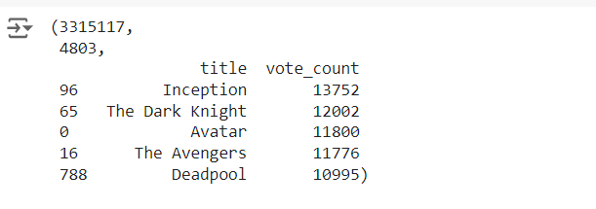

Pick three users(U1,U2,U3)

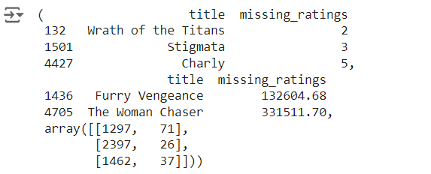

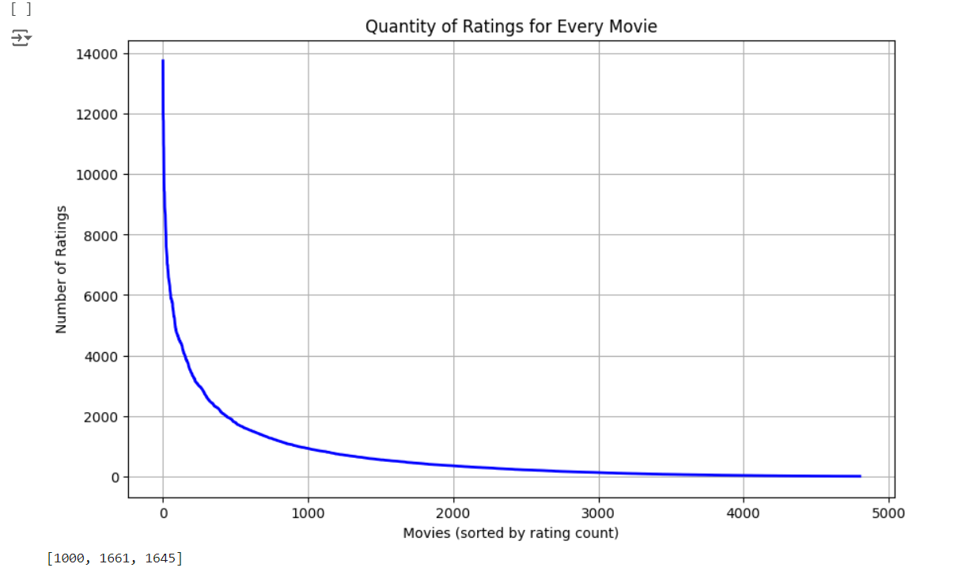

Summary of the Comparison of part 1 and 2

Case study 1.1:

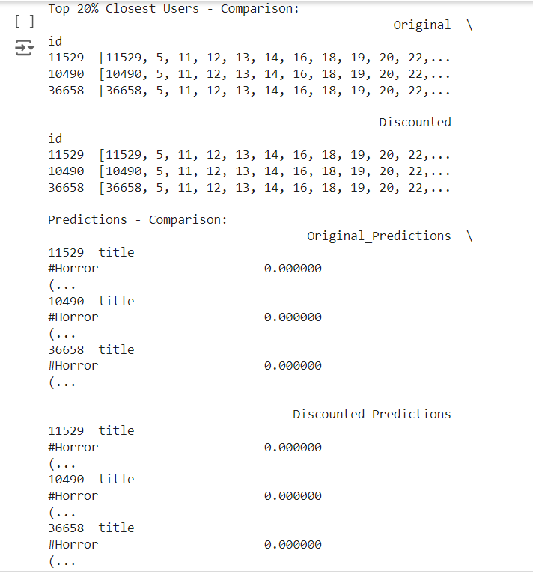

Case study 1.2

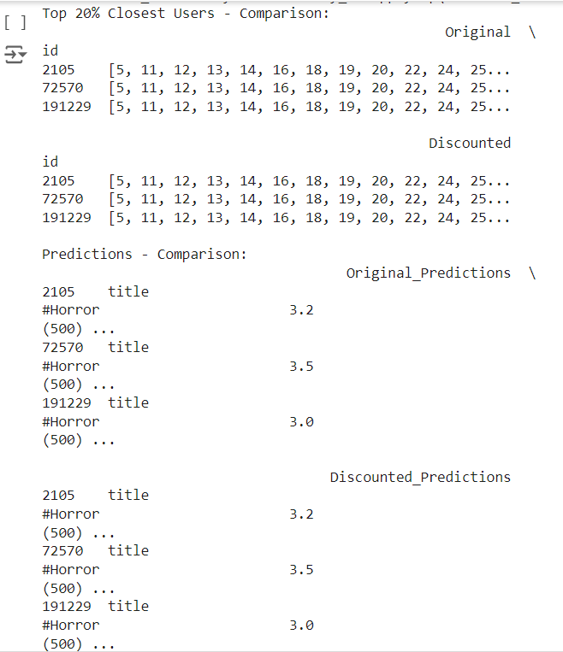

Case study1.3

